1. Create project like the following figure:

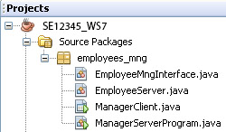

1. Design the GUI like the following figure**(10 marks)**

* At client side:
  + Initially, a list of employees is supplied from server will be presented on a table of the GUI.
  + User can
    - Add new employee ( the employee’s code must have the format E000 and it is not duplicated with existing employee codes.
    - Remove an employee.
    - Update employee details.
    - Save the list on server.

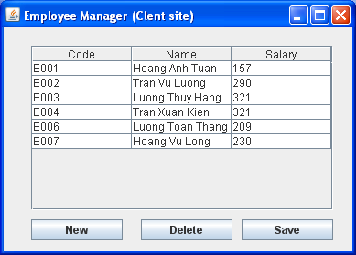

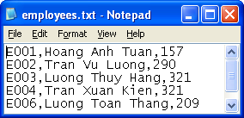

Performance requirements:

Using Java RMI create program as described above.